國立雲林科技大學圖資處藝術中心展覽申請作業要點
112.07.19 112年第1次諮詢委員會議通過
114.08.12 114年第1次諮詢委員會議修訂通過

- 圖書資訊處藝術中心致力於推動多元化的藝文展覽活動，以培養觀眾美感經驗，提升藝術欣賞涵養。為鼓勵藝壇優異的藝文創作者分享作品與創作理念，開放本館藝術中心展覽空間之申請。
- 申請資格：凡從事藝術創作之個人或團體皆可提出申請。
- 申請方式
（一）1月1日至6月30日受理翌年度檔期之申請。
（二）申請展覽應檢附下列資料：
1.填具「國立雲林科技大學圖書資訊處藝術中心展覽場地使用申請表」乙份。
2.填具「雲科大圖書資訊藝術中心展覽場地使用申請展覽企劃書」乙份。
3.代表展出作品資料（「送審作品相片明細表」及「送審作品黏貼表」）：
(1)個人或聯展：作品照片10-15張，聯展每人至少需提出作品照片2張，不得有一人照片過半數(附表3和4)，立體或其他裝置請另外提供完整規劃圖。
(2)藝術團體：畫冊及展者名冊各壹份。
4.展覽需檢附之資料，一律以數位電子檔或紙本送件。
四 、審查：
- 藝術展覽申請人數，若超出預定展覽檔期，得召開「諮詢委員會」進行審查，討論排定邀請展順序，並於審查通過後函知申請人(或團體)安排展出檔期。
- 申請未通過者，由圖書資訊函知，並寄還原送審查資料。
- 申請者展出後，需間隔二年方可再提出申請。
- 申請人數未達展覽檔期時，由本館邀請藝術家展出，不另召開會諮詢委員會議。
- 檔期安排：
- 展期以四至六週為原則，展出時間由圖書資訊排定。
- 申請人(或團體)在接獲通知後請依排定之檔期按時展出，如因故無法如期
展出，請於收到通知後三十天內通知圖書資訊，且一年內不得再向本館提出展覽申請。
六、場地使用原則：
（一）展出作品凡經檢舉抄襲他人作品屬實，即停止展出。
（二）展場開放時間為每週一至週六，上午九時至下午五時；寒暑假同圖書館開館時間；逢國定假 日、連假及選舉日期間及週日休館，申請者需配合圖書資訊處藝術中心開放時間內進行撤佈展。
（三）展場之佈置應會同圖書資訊處之承辦業務人員勘察，並於展出前一日下午五時前完成佈展，展覽作品應於結束次日開始撤場。
（四）展覽場地不得放置與展出無關之物品；展覽後應負責清理場地，恢復原貌。
（五）展出者如欲舉辦開幕茶會、音樂會等相關活動，所需費用自行負責，並與圖書資訊處協調辦理。
（六）展出作品須依原申請展覽計畫執行，凡有更動須事先徵得圖書資訊處同意。
（七）因應展出需求而欲改變展覽場地者，經與圖書資訊處協商同意後辦理。
（八）展出期間內，展出者與圖書資訊處共同負責展品安全之維護，惟遇人力不可抗拒情事或作品本身結構、製作及裝置不良而損壞者，圖書資訊處不予負責。若有貴重或易碎作品，則展出者需以安全考量自行加裝保護設施，並自費投保。
（九）展出期間不得有標價或任何商業行為，違反者圖書資訊處可立即取消該展出，並永久取消展出資格。
(十) 使用期間如場地公物或設備有毀損者，申請人需負責賠償或回復原狀之責任。
七、運送與保險：圖書資訊處提供展覽展品之運送、場地佈置與卸展服務之部份經費。如為易碎品或易變形之特殊材質，不在運送範圍內。
八、文宣品製作：請柬、海報及宣傳資料，由展出者提供，並由圖書資訊處修改或設計核校通過後製作，輸出費用由圖書資訊處負責，請柬格式請參考圖書資訊處格式範本。展出者自行印製之文宣資料，內容須事先經圖書資訊處認可。
九、作品圖像使用：為推廣活動及製作文宣，圖書資訊處於展覽期間對展出作品有拍照、複製、影像使用之權利。
十、本要點如有未盡事宜，由圖書資訊處與申請單位主管協議之。
十一、本要點經圖書資訊處藝術中心諮詢委員會通過，陳請校長核定後實施，修正時亦同。

National Yunlin University of Science and Technology Office of Library and Information Services Art Center Guidelines for Exhibition Application

Approved by 1st the Advisory Committee meeting on July 19, 2023
Revised at the 1st Advisory Committee Meeting of Academic Year 2025 (August 12, 2025)

1. Purpose
(1) The Art Center of the Library and Informatiion Center at National Yunlin University of Science and Technology is committed to promoting diverse art and cultural exhibitions to cultivate aesthetic experiences and enhance artistic appreciation.
(2) To encourage outstanding creators in the art world to share their works and creative visions, the Library and Informatiion Center opens its Art Center exhibition space for public applications.
2. Eligibility
(1) Individuals or groups engaged in artistic creation are eligible to apply.
3. Application Process
(1) Applications for the following year's exhibition schedule are accepted from January 1 to June 30.
(2) Applicants must submit the following documents:
A. One completed application form for the use of the exhibition space at the Art Center.
B. One completed exhibition proposal form for the use of the Art Center.
C. Documentation of representative works for review:
a. Individual or joint exhibitions: 10–15 photos of works; in joint exhibitions, each
participant must submit at least two photos, with no single person’s works exceeding
half the total (Forms 3 and 4). For 3D or installation works, include full layout plans.
b. Art groups: One exhibition catalog and one list of participants.
D. All materials must be submitted either in digital format or a printed copy.
4. Review Process
(1) If the number of applications exceeds available slots, the Advisory Committee will convene to
review and prioritize exhibition scheduling. Approved applicants will be notified.
(2) Rejected applicants will be formally notified and their submitted materials returned.
(3) A minimum of two years must pass before a previous exhibitor can reapply.
(4) If the number of applicants is fewer than the available slots, the Library and Informatiion Center
may invite artists directly without holding a committee meeting.
5. Exhibition Schedule
(1) Exhibition periods typically span 4 to 6 weeks and are scheduled by the Library and
Informatiion Center.
(2) Upon notification, applicants must adhere to the assigned schedule. If unable to exhibit as
scheduled, the applicant must notify the Library and Informatiion Center within 30 days; failure
to do so will result in ineligibility to apply within the next year.
6. Use of Exhibition Space
(1) Any exhibit found to have plagiarized others’ work will be immediately withdrawn.
(2) Exhibition hours are Monday to Saturday, 9:00 AM to 5:00 PM. The venue is closed on
Sundays, national holidays, and election days. Set-up and removal must align with these hours.
(3) Setup must be coordinated with Library and Informatiion Center staff and completed by 5:00
PM the day before the opening; dismantling must begin the day after the exhibition ends.
(4) The exhibition space must not contain unrelated items and must be restored to its original state
after use.
(5) If hosting an opening reception, concert, or other related events, all expenses must be covered
by the exhibitor and coordinated with the Library and Informatiion Center.
(6) Exhibits must align with the original proposal; any changes require prior approval from the
Library and Informatiion Center.
(7) Changes to the venue layout must be approved by the Library and Informatiion Center.
(8) Both the exhibitor and the Library and Informatiion Center share responsibility for exhibition
safety; however, the Library and Informatiion Center is not liable for damage caused by force
majeure, poor structural integrity, or improper installation. Exhibitors of fragile or valuable
items must install protective measures and are encouraged to purchase insurance at their own
expense.
(9) Commercial activities such as pricing or sales are strictly prohibited. Violations will result in
immediate termination of the exhibition and permanent disqualification.
(10) Applicants are responsible for any damage to facilities or equipment and must compensate or
restore them to their original condition.
7. Transportation and Insurance
The Library and Informatiion Center provides partial support for the transport, installation, and dismantling of exhibition items. Fragile or deformable materials are excluded from transport services.
8. Promotional Materials
(1) Invitations, posters, and publicity materials must be provided by the exhibitor. The Library and Informatiion Center will revise, design, and approve the final versions. Output costs are covered by the Library.
(2) For self-produced promotional materials, prior approval from the Library and Informatiion Center is required.
(3) Invitations should conform to the Library and Informatiion Center’s template.
9. Image Use of Exhibited Works
The Library and Informatiion Center retains the right to photograph, reproduce, and use images of the exhibits during the exhibition period for promotional and publicity purposes.
10. Unspecified Matters
Any matters not covered in these guidelines shall be negotiated between the Library and Informatiion Center and the applicant’s responsible unit.
11. Implementation
These guidelines shall take effect upon approval by the Advisory Committee and ratified by the President. Revisions follow the same procedure.

附件1
雲科大圖書資訊處藝術中心展覽場地使用申請表
Exhibition Application Form
Date 填表日期 年(Y) 月 (M) 日(D)
展覽名稱
Name of Exhibition
作品類型  Type of Art |  |  |  |  | 件數  Quantity |  |  |  | 作品規格  Size
申請場地  Venue |  | □雲創廳 Art Muse（原創意廳） □雲想廳 Art Hub（原展覽廳）□全藝術中心 Both（請參考附件5）
上次在本中心展出時間  Last Exhibition at the Center |  | □無 None □ 有 (年) In Year ______
預定展出之年月份  Preferred Exhibition Dates |  | 年 月或 年 月  (Year) (Month) or (Year) (Month)
申請人姓名  Name of Applicant |  |  |  |  |  | 出生年月日  Date of Birth |  | 年 月 日  (Y) （M） （D）
通訊住址  Correspondence Address |  | □□□
電話  Tel. |  |  | 傳真  Fax |  |  |  |  | 行動  Mobile Phone
E-mail
申請人學經歷
Educational Background and Working Experience
展出個人（團體）畫歷與得獎、參展經歷簡介
Exhibitions, Honors, and Awards Competitions

附件2
雲科大圖書資訊處藝術中心展覽場地使用申請
展覽企畫書 Exhibition Plan
展覽名稱
Name of the Exhibition （Chinese)
展覽名稱(英文)
Name of the Exhibition (English)
展覽簡介  A Brief Introduction of the Exhibition  (200字) | 展覽介紹（整個展覽為主題）The theme of the exhibition
創作概述與理念  A Brief Description about the Concept of the Art Works  (200字) | 創作發想、過程與理念（以展覽作品創作為主題）the concept and creative processes of the artworks that will be exhibited
展覽場地初步規劃 說明  A Description of the Preliminary Exhibition Plan | 展覽時需要用到之器材（展台展板等）以及場域使用的初步規劃；如為裝置藝術，請提供示意圖 A schematic diagram of not only the facilities needed to be used for installation art but also the preliminary planning of how to use the site should be provided..
附件3
送審作品之相片明細表
List of works (submitted for review)
（國立雲林科技大學展覽場地使用申請）
編號  No. | 標 題  Title | 創作年代  Time Period of Creation | 材質及尺寸  Type and size
1.
2.
3.
4.
5.
6.
7.
8.
9.
10.
注意Note：
- 以畫冊參與審查者不必填寫:
Those who participate in the review with a portfolio do not have to fill out this form.
- 本表如不敷使用，請自行增加欄位
If the columns in this form are insufficient, please add more when necessary.

送審作品黏貼表 Pictures of works
附件4
《須檢附展出作品照片6-8張，照片請黏貼於此頁，俾本中心開審查會時參考》
Please attach 6-8 pictures using this form
請黏貼照片
Attach Picture
請黏貼照片
本表不敷使用，請自行列印This form is re-printable.
電子檔請提供清晰、畫質較好的照片，如提交紙本，請黏貼4x6之照片Please provide a clear photo with high resolution and have it attached as the electronic file. Alternatively, if you submit a paper copy, please paste 4x6 photos
Attach Picture
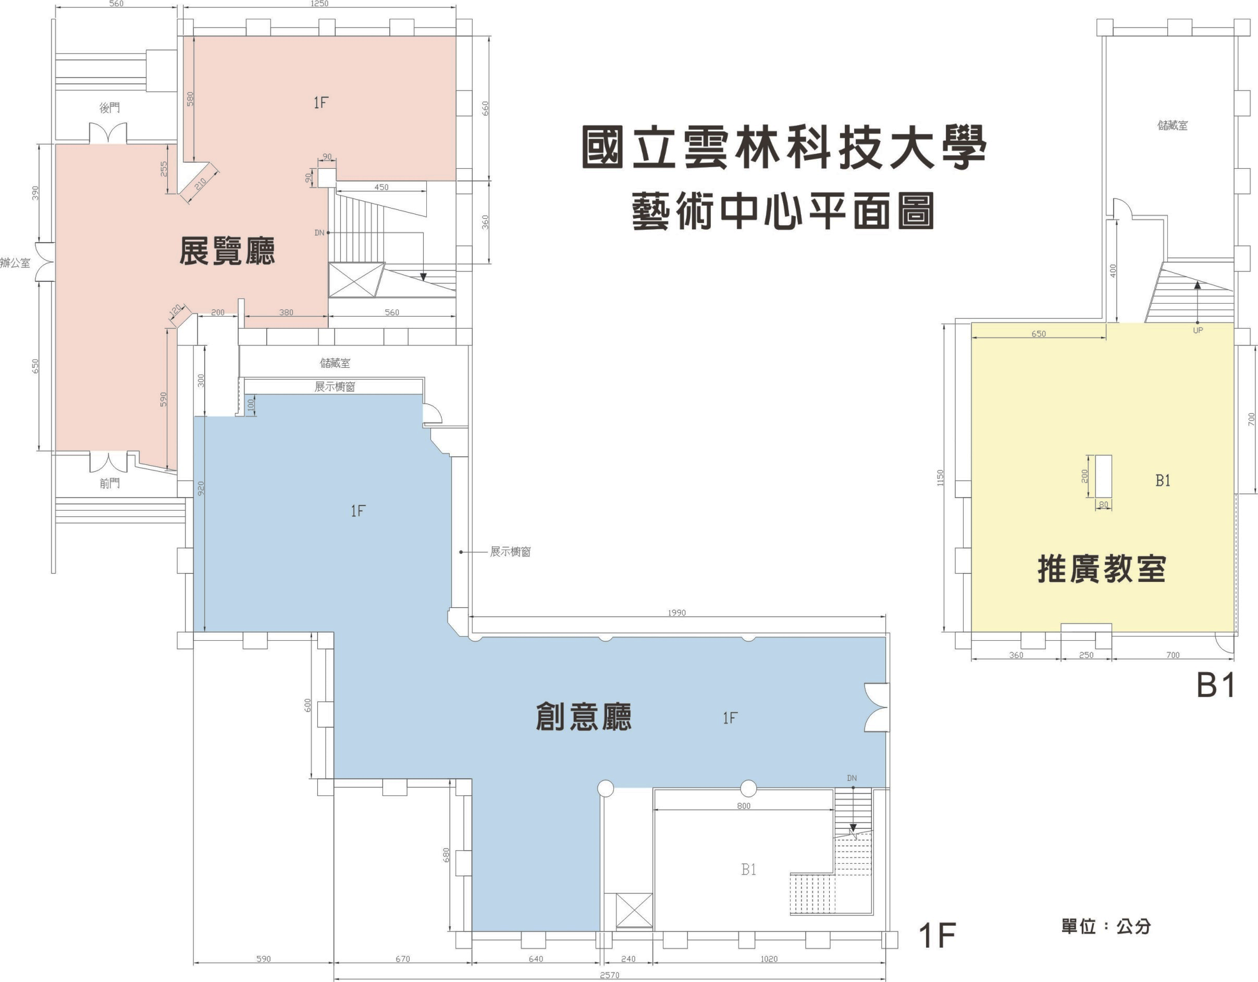
國立雲林科技大學圖書資訊處藝術中心展覽場地平面圖 (Floor Plan)
單位：公分 by cm
雲創廳 Art Muse
雲想廳Art Hub
附件5

