國立雲林科技大學圖書館藝術中心展覽申請作業要點
112.07.19 112年第1次諮詢委員會議通過

- 國立雲林科技大學圖書館藝術中心（以下簡稱本館）致力於推動多元化的藝文展覽活動，以培養觀眾美感經驗，提升藝術欣賞涵養。為鼓勵藝壇優異的藝文創作者分享作品與創作理念，開放本館藝術中心展覽空間之申請。
- 申請資格：凡從事藝術創作之個人或團體皆可提出申請。
- 申請方式
（一）1月1日至6月30日受理翌年度檔期之申請。
（二）申請展覽應檢附下列資料：
1.填具「國立雲林科技大學圖書館藝術中心展覽場地使用申請表」乙份。
2.填具「雲科大圖書館藝術中心展覽場地使用申請展覽企劃書」乙份。
3.代表展出作品資料（「送審作品相片明細表」及「送審作品黏貼表」）：
(1)個人或聯展：作品照片10-15張，聯展每人至少需提出作品照片2張，不得有一人照片過半數(附表3和4)，立體或其他裝置請另外提供完整規劃圖。
(2)藝術團體：畫冊及展者名冊各壹份。
4.展覽需檢附之資料，一律以數位電子檔或紙本送件。
四 、審查：
- 藝術展覽申請人數，若超出預定展覽檔期，得召開「諮詢委員會」進行審查，討論排定邀請展順序，並於審查通過後函知申請人(或團體)安排展出檔期。
- 申請未通過者，由本館函知，並寄還原送審查資料。
- 申請者展出後，需間隔二年方可再提出申請。
- 申請人數未達展覽檔期時，由本館邀請藝術家展出，不另召開會諮詢委員會議。
- 檔期安排：
- 展期以四至六週為原則，展出時間由本館排定。
- 申請人(或團體)在接獲通知後請依排定之檔期按時展出，如因故無法如期
展出，請於收到通知後三十天內通知本館，且一年內不得再向本館提出展覽申請。
六、場地使用原則：
（一）展出作品凡經檢舉抄襲他人作品屬實，即停止展出。
（二）展場開放時間為每週一至週六，上午九時十分至下午五時；逢國定假 日、連假及選舉日期間及週日休館，申請者需配合本館藝術中心開放時間內進行撤佈展。
（三）展場之佈置應會同本館之承辦業務人員勘察，並於展出前一日下午五時前完成佈展，展覽作品應於結束次日開始撤場。
（四）展覽場地不得放置與展出無關之物品；展覽後應負責清理場地，恢復原貌。
（五）展出者如欲舉辦開幕茶會、音樂會等相關活動，所需費用自行負責，並與本館協調辦理。
（六）展出作品須依原申請展覽計畫執行，凡有更動須事先徵得本館同意。
（七）因應展出需求而欲改變展覽場地者，經與本館協商同意後辦理。
（八）出期間內，展出者與本館共同負責展品安全之維護，惟遇人力不可抗拒情事或作品本身結構、製作及裝置不良而損壞者，本館不予負責。若有貴重或易碎作品，則展出者需以安全考量自行加裝保護設施，並自費投保。
（九）展出期間不得有標價或任何商業行為，違反者本館可立即取消該展出，並永久取消展出資格。
(十)使用期間如場地公物或設備有毀損者，申請人需負責賠償或回復原狀之責任。
七、運送與保險：本館提供展覽展品之運送、場地佈置與卸展服務之部份經費。如為易碎品或易變形之特殊材質，不在運送範圍內。
八、文宣品製作：請柬、海報及宣傳資料，由展出者提供，並由本館修改或設計核校通過後製作，輸出費用由本館負責，請柬格式請參考本館格式範本。展出者自行印製之文宣資料，內容須事先經本館認可。
九、作品圖像使用：為推廣活動及製作文宣，本館於展覽期間對展出作品有拍照、複製、影像使用之權利。
十、其他：
- 有意申請展覽者，請至本館藝術中心網站下載申請表：https://www.yuntechartcenter.com/exhibitionapplication
- 電子檔申請請寄送artcenter@yuntech.edu.tw，並於主旨中註名「申請展覽─（展覽名稱）」
- 紙本申請請寄送「640雲林縣斗六市大學路三段123號 國立雲林科技大學圖書館 收」或親送至本館藝術中心辦公室。
十一、本要點如有未盡事宜，由本館與申請單位主管協議之。
十二、本要點經本館「諮詢委員會議」通過後實施，修正時亦同。

National Yunlin University of Science and Technology Library Art Center
Regulations for Exhibition Application

Approved by 1st the Advisory Committee meeting on July 19, 2023
    - The Art Center of the National Yunlin University of Science and Technology Library (hereinafter referred to as the Library) is committed to promoting diverse art and cultural exhibitions to cultivate aesthetic experiences and enhance art appreciation. To encourage outstanding artists and cultural creators to share their works and creative concepts, the Library's Art Center exhibition space is open for application.
    - Eligibility: Any individual or group engaged in artistic creation can apply.
    - Application Method:
- Applications for the following year's schedule are accepted from January 1 to June 30.
- The exhibition application should include the following materials:
- A completed "National Yunlin University of Science and Technology Library Art Center Exhibition Venue Application Form".
- A completed "Yuntech Library Art Center Exhibition Venue Application Exhibition Proposal".
- Representative exhibition work information ("Exhibition Work Photo Detail Form" and "Exhibition Work Paste Form"):
  - Individual or joint exhibition: 10-15 photos of works, each person in a joint exhibition must submit at least 2 photos of works, and no one person can have more than half of the photos (Appendix 3 and 4). For three-dimensional or other installations, please provide a complete planning diagram.
  - Art groups: One copy of the album and exhibitor roster.
- All required exhibition materials must be submitted in digital electronic format or hard copy.

- Review:
- If the number of art exhibition applicants exceeds the amount of scheduled exhibition period, a "Consultation Committee" may be convened for review, to discuss and determine the order of invitation exhibitions, and to notify the applicant (or group) of the exhibition schedule after the review is passed.
- Applicants who do not pass the review will be notified by the Library, and the original review materials will be returned.
- After an applicant's exhibition, they must wait two years before applying again.
- If the number of applicants does not reach the exhibition schedule, the Library will invite artists to exhibit without convening a Consultation Committee meeting.

- Schedule Arrangement:
- The exhibition period is generally four to six weeks, and the exhibition time is arranged by the Library.
- After receiving the notification, the applicant (or group) should exhibit on time according to the scheduled schedule. If they cannot exhibit as scheduled due to reasons, they should notify the Library within thirty days after receiving the notification, and they cannot apply for an exhibition at the Library within one year.

- Venue Use Principles:
- If an exhibited work is reported and confirmed to be plagiarized from others, the exhibition will be stopped immediately.
- The exhibition venue is open from Monday to Saturday, from 9:10 am to 5:00 pm; it is closed on national holidays, long weekends, election dates, and Sundays. Applicants need to set up and dismantle the exhibition within the opening hours of the Library's Art Center.
- The layout of the exhibition venue should be inspected with the Library's responsible staff, and the exhibition should be set up before 5:00 pm the day before the exhibition. The exhibition works should start to be dismantled the day after the end.
- Items unrelated to the exhibition should not be placed in the exhibition venue; after the exhibition, the exhibitor should be responsible for cleaning the venue and restoring it to its original state.
- If the exhibitor wants to hold an opening tea party, concert, or other related activities, they need to bear the costs themselves and coordinate with the Library.
- The exhibited works must be executed according to the original exhibition plan, and any changes must be approved by the Library in advance.
- If you want to change the exhibition venue due to exhibition needs, you can do so after consulting and agreeing with the Library.
- During the exhibition period, the exhibitor and the Library are jointly responsible for the maintenance of the exhibits. However, the Library is not responsible for damages caused by force majeure or poor structure, production, and installation of the works themselves. If there are valuable or fragile works, the exhibitor needs to install protective facilities for safety considerations and insure them at their own expense.
- There should be no pricing or any commercial behavior during the exhibition period. Violators will have their exhibition cancelled immediately by the Library and will be permanently disqualified from exhibiting.
- If public property or equipment in the venue is damaged during the use period, the applicant is responsible for compensation or restoration.

- Transportation and Insurance: The Library provides partial funding for the transportation of exhibition items, venue setup, and dismantling services. Fragile or easily deformed special materials are not included in the transportation scope.
- Production of Publicity Materials: Invitations, posters, and promotional materials are provided by the exhibitor, and are produced after being modified or designed and approved by the Library. The output cost is borne by the Library. Please refer to the Library's format for the invitation format. The content of publicity materials printed by the exhibitor themselves must be approved by the Library in advance.
- Use of Work Images: For the promotion of activities and the production of publicity, the Library has the right to photograph, reproduce, and use images of the exhibited works during the exhibition period.
- Others:
- Those who intend to apply for an exhibition, please download the application form from the Library Art Center website: https://www.yuntechartcenter.com/exhibitionapplication
- For electronic file applications, please send to artcenter@yuntech.edu.tw, and note in the subject "Exhibition Application - (Exhibition Name)".
- For hard copy applications, please send to "123 University Road Section 3, Douliu City, Yunlin County 640, National Yunlin University of Science and Technology Library" or deliver it to the Library Art Center office.

- For matters not covered in these regulations, they will be negotiated between the Library and the applicant's supervisor.
- These regulations are implemented after being passed by the Library's "Consultation Committee Meeting", and the same applies when they are amended.

附件1
雲科大圖書館藝術中心展覽場地使用申請表
Exhibition Application Form
Date 填表日期 年(Y) 月 (M) 日(D)
展覽名稱
Name of Exhibition
作品類型  Type of Art |  |  |  |  | 件數  Quantity |  |  |  | 作品規格  Size
申請場地  Venue |  | □雲創廳 Art Muse（原創意廳） □雲想廳 Art Hub（原展覽廳）□全藝術中心 Both（請參考附件5）
上次在本中心展出時間  Last Exhibition at the Center |  | □無 None □ 有 (年) In Year ______
預定展出之年月份  Preferred Exhibition Dates |  | 年 月或 年 月  (Year) (Month) or (Year) (Month)
申請人姓名  Name of Applicant |  |  |  |  |  | 出生年月日  Date of Birth |  | 年 月 日  (Y) （M） （D）
通訊住址  Correspondence Address |  | □□□
電話  Tel. |  |  | 傳真  Fax |  |  |  |  | 行動  Mobile Phone
E-mail
申請人學經歷
Educational Background and Working Experience
展出個人（團體）畫歷與得獎、參展經歷簡介
Exhibitions, Honors, and Awards Competitions

附件2
雲科大圖書館藝術中心展覽場地使用申請
展覽企畫書 Exhibition Plan
展覽名稱
Name of the Exhibition （Chinese)
展覽名稱(英文)
Name of the Exhibition (English)
展覽簡介  A Brief Introduction of the Exhibition  (200字) | 展覽介紹（整個展覽為主題）The theme of the exhibition
創作概述與理念  A Brief Description about the Concept of the Art Works  (200字) | 創作發想、過程與理念（以展覽作品創作為主題）the concept and creative processes of the artworks that will be exhibited
展覽場地初步規劃 說明  A Description of the Preliminary Exhibition Plan | 展覽時需要用到之器材（展台展板等）以及場域使用的初步規劃；如為裝置藝術，請提供示意圖 A schematic diagram of not only the facilities needed to be used for installation art but also the preliminary planning of how to use the site should be provided..
附件3
送審作品之相片明細表
List of works (submitted for review)
（國立雲林科技大學展覽場地使用申請）
編號  No. | 標 題  Title | 創作年代  Time Period of Creation | 材質及尺寸  Type and size
1.
2.
3.
4.
5.
6.
7.
8.
9.
10.
注意Note：
- 以畫冊參與審查者不必填寫:
Those who participate in the review with a portfolio do not have to fill out this form.
- 本表如不敷使用，請自行增加欄位
If the columns in this form are insufficient, please add more when necessary.

送審作品黏貼表 Pictures of works
附件4
《須檢附展出作品照片6-8張，照片請黏貼於此頁，俾本中心開審查會時參考》
Please attach 6-8 pictures using this form
請黏貼照片
Attach Picture
請黏貼照片
本表不敷使用，請自行列印This form is re-printable.
電子檔請提供清晰、畫質較好的照片，如提交紙本，請黏貼4x6之照片Please provide a clear photo with high resolution and have it attached as the electronic file. Alternatively, if you submit a paper copy, please paste 4x6 photos
Attach Picture
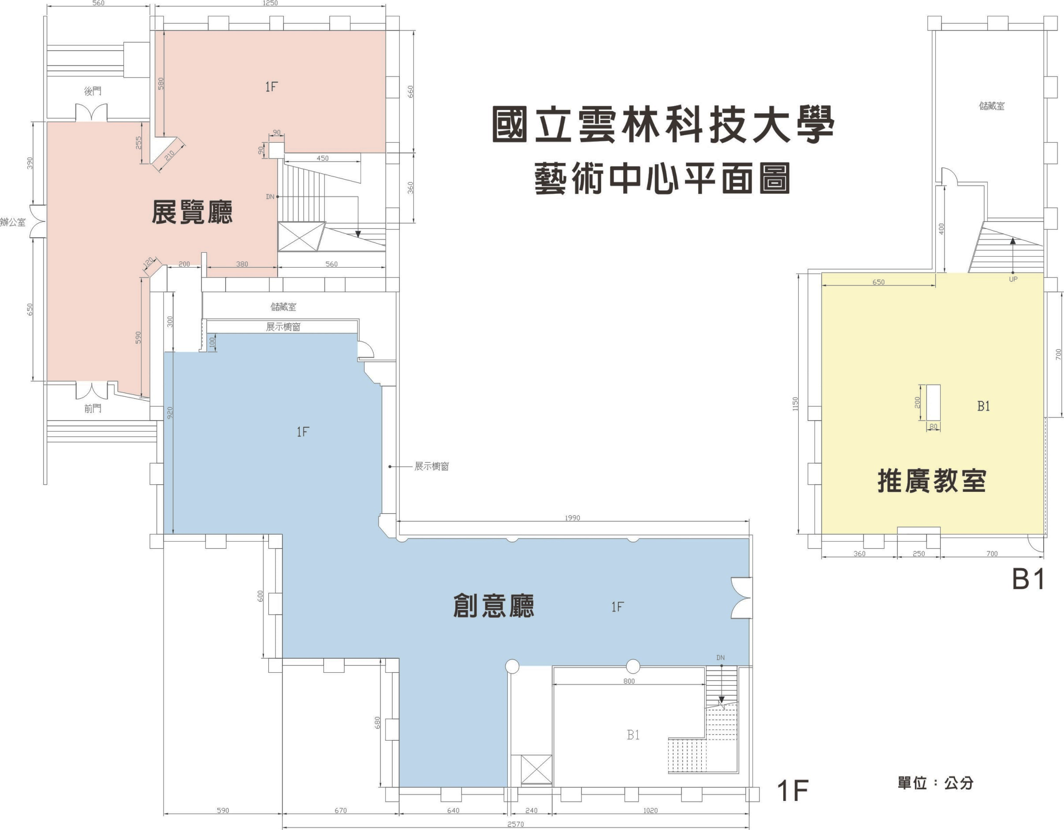
國立雲林科技大學圖書館藝術中心展覽場地平面圖 (Floor Plan)
單位：公分 by cm
雲創廳 Art Muse
（原創意廳）
雲想廳Art Hub
（原展覽廳）
附件5

