國立雲林科技大學藝術中心展覽申請作業要點
112年5月31日111學年度第8次館務會議通過
112年7月19日112年第1次藝術中心諮詢委員會議修正通過
113年7月23日113年第1次藝術中心諮詢委員會議修正通過
114年8月12日114年第1次藝術中心諮詢委員會議修正通過
115年7月22日115年第1次藝術中心諮詢委員會議修正通過

- 國立雲林科技大學致力於推動多元化的藝文展覽活動，以培養觀眾美感經驗，提升藝術欣賞涵養。為鼓勵藝壇優異的藝文創作者分享作品與創作理念，開放本校藝術中心展覽空間之申請。
- 申請資格：凡從事藝術創作之個人或團體皆可提出申請。
- 申請方式：
(一)每年1月1日至6月30日受理翌年度檔期之申請。
(二)申請展覽填需具本校藝術中心展覽場地使用申請表，並檢附展覽企劃書、展出作品明細及作品相片6-8張。
(三)聯展申請者需檢附作品相片10-15張，每人至少需檢附作品照片2張，不得有一人照片過半數。
(四)藝術團體申請者，另需檢付展者名冊及畫冊各乙份。
(五)展覽申請需填具及檢附資料，一律以數位電子檔送件。
- 審查：
(一)藝術展覽申請由本校藝術中心諮詢委員會審查、討論及排定展覽順序，並於審查後函知申請人（或團體）審查結果及展出檔期。
(二)申請者展出後，需間隔二年方可再提出申請。
(三)申請人數未達展覽檔期時，得由本校藝術中心邀請藝術家展出，不另召開諮詢委員會審議。
- 檔期安排：
(一)展期以四至六週為原則，展出時間由本校參酌申請者需求排定。
(二)申請人（或團體）在接獲通知後請依排定之檔期按時展出，如因故無法如期展出，請於收到通知後三十天內通知本校，且一年內不得再向本校提出展覽申請。
- 場地使用原則：
(一)展出作品凡經檢舉抄襲他人作品屬實，即停止展出。
(二)展場開放時間為每週一至週六，上午九時至下午五時；寒暑假同圖書館開館時間；逢國定假日、連假及選舉日期間及週日休館，申請者需配合本校藝術中心開放時間內進行撤佈展。
(三)展場之佈置應會同本校藝術中心之承辦業務人員勘察，並於展出前一日下午五時前完成佈展，展覽作品應於結束次日開始撤場。
(四)展覽場地不得放置與展出無關之物品；展覽後應負責清理場地，恢復原貌。
(五)展出者如欲舉辦開幕茶會、音樂會等相關活動，所需費用自行負責，並與本校藝術中心協調辦理。
(六)展出作品須依原申請展覽計畫執行，凡有更動須事先徵得本校藝術中心同意。
(七)因應展出需求而欲改變展覽場地者，經與本校藝術中心協商同意後辦理。
(八)展出期間內，展出者與本校藝術中心共同負責展品安全之維護，惟遇人力不可抗拒情事或作品本身結構、製作及裝置不良而損壞者，本校藝術中心不予負責。若有貴重或易碎作品，則展出者需以安全考量自行加裝保護設施，並自費投保。
(九)展出期間不得有標價或任何商業行為，違反者本校藝術中心可立即取消該展出，並永久取消展出資格。
(十)使用期間如場地公物或設備有毀損者，申請人需負責賠償或回復原狀之責任。
- 運送與保險：本校藝術中心提供展覽展品之運送、場地佈置與卸展服務之部份經費。如為易碎品或易變形之特殊材質，不在運送範圍內。
- 文宣品製作：請柬、海報及宣傳資料，由展出者提供，並由本校藝術中心修改或設計核校通過後製作，輸出費用由本校負責，請柬格式請參考本校藝術中心格式範本。展出者自行印製之文宣資料，內容須事先經本校藝術中心認可。
- 作品圖像使用：為推廣活動及製作文宣，本校藝術中心於展覽期間對展出作品有拍照、複製、影像使用之權利。
- 本要點如有未盡事宜，由本校藝術中心與申請者協議之。
十一、本要點經本校藝術中心諮詢委員會通過，陳請校長核定後實施，修正時亦同。
National Yunlin University of Science and Technology Art Center Guidelines for Exhibition Application

Approved at the 1st Advisory Committee Meeting of Academic Year 2023 (July 19, 2023)
Revised at the 1st Advisory Committee Meeting of Academic Year 2024 (July 23, 2024)
Revised at the 1st Advisory Committee Meeting of Academic Year 2025 (August 12, 2025)
Revised at the 1st Advisory Committee Meeting of Academic Year 2026 (July 22, 2026)

1. Purpose
National Yunlin University of Science and Technology (hereinafter referred to as "the University") is committed to promoting diverse art exhibitions to cultivate the aesthetic experiences of the audience and enhance art appreciation. To encourage outstanding artists to share their works and creative concepts, the Art Center’s exhibition space is open for application.
2. EligibilityAny individual or group engaged in art creation is eligible to apply.
3. Application Procedure
(1) Applications for the following year's exhibition schedule are accepted annually from January 1 to June 30.
(2) Applicants must fill out the Art Center’s exhibition venue application form and provide an exhibition proposal, a list of exhibited works, and 6-8 photos of the works.
(3) For group exhibitions, 10-15 photos must be provided. Each participant must provide at least 2 photos, and no single person’s photos shall exceed half of the total.
(4) Artistic organizations must also provide a list of exhibitors and one copy of an art catalog.
(5) All application documents and materials must be submitted as digital electronic files.
4. Review Process
(1) Applications are reviewed, discussed, and scheduled by the University’s Art Center Advisory Committee. Applicants (or groups) will be notified of the results and the scheduled exhibition period by mail after the review.
(2) Applicants may only re-apply for an exhibition after a two-year interval from their previous exhibition.
(3) If the number of applicants is fewer than the available exhibition slots, the Art Center may invite artists to exhibit without convening a formal Advisory Committee meeting.
5. Exhibition Scheduling
(1)The exhibition period is generally four to six weeks. The University will schedule the specific dates considering the applicant’s needs.
(2) Upon receiving notification, the applicant (or group) must exhibit according to the scheduled period. If unable to exhibit as planned, the applicant must notify the University within 30 days of receiving the notification. Failure to do so will result in a one-year suspension of eligibility to apply for exhibitions at the University.
6. Venue Usage Principles
(1) If a work is proven to be plagiarized, the exhibition will be terminated immediately.
(2) The exhibition venue is open from Monday to Saturday, 9:00 AM to 5:00 PM. During winter and summer vacations, hours follow the library schedule. The venue is closed on national holidays, long weekends, election days, and Sundays. Applicants must cooperate with the Art Center’s opening hours for setup and dismantling.
(3) Venue setup must be coordinated with the Art Center’s staff. Setup must be completed by 5:00 PM the day before the exhibition starts. Dismantling should begin on the day following the end of the exhibition.
(4) No items unrelated to the exhibition may be placed in the venue. Applicants are responsible for cleaning the venue and restoring it to its original state after the exhibition.
(5) Applicants wishing to hold opening receptions, concerts, or related activities must bear the costs and coordinate with the Art Center.
(6) Exhibited works must follow the original application plan. Any changes must receive prior consent from the Art Center.
(7) Any venue modifications required for the exhibition must be agreed upon by the Art Center.
(8) During the exhibition, the applicant and the Art Center are jointly responsible for the safety of the works. However, the Art Center is not liable for damage caused by force majeure or issues related to the work’s structure, production, or installation. For precious or fragile works, the exhibitor should provide additional protection and obtain insurance at their own expense.
(9) No price tags or commercial activities are allowed during the exhibition. Violations will result in the immediate cancellation of the exhibition and permanent loss of eligibility to exhibit.
(10) Applicants are liable for compensation or restoration if public property or equipment is damaged during the usage period.
7. Transportation and Insurance
The Art Center provides partial funding for the transportation of works, venue setup, and dismantling services. Fragile or easily deformed materials are excluded from the transportation service.
8. Promotional Materials
Invitations, posters, and promotional materials shall be provided by the exhibitor and finalized after being modified or designed/verified by the Art Center. The University bears the printing costs. The format of invitations should refer to the Art Center’s templates. Any self-printed promotional materials must be approved by the Art Center in advance.
9. Image Use of Exhibited Works
For promotion and the production of materials, the Art Center reserves the right to photograph, replicate, and use images of the exhibited works during the exhibition period.
10. Unspecified Matters: Any matters not covered in these guidelines shall be negotiated between the Art Center and the applicant.
11. Implementation
These guidelines shall take effect upon approval by the Art Center Advisory Committee and ratification by the President. The same process applies to any future amendments.

附件1
雲科大圖書資訊處藝術中心展覽場地使用申請表
Exhibition Application Form
Date 填表日期 年(Y) 月 (M) 日(D)
展覽名稱
Name of Exhibition
作品類型  Type of Art |  |  |  |  | 件數  Quantity |  |  |  | 作品規格  Size
申請場地  Venue |  | □雲創廳 Art Muse（原創意廳） □雲想廳 Art Hub（原展覽廳）□全藝術中心 Both（請參考附件5）
上次在本中心展出時間  Last Exhibition at the Center |  | □無 None □ 有 (年) In Year ______
預定展出之年月份  Preferred Exhibition Dates |  | 年 月或 年 月  (Year) (Month) or (Year) (Month)
申請人姓名  Name of Applicant |  |  |  |  |  | 出生年月日  Date of Birth |  | 年 月 日  (Y) （M） （D）
通訊住址  Correspondence Address |  | □□□
電話  Tel. |  |  | 傳真  Fax |  |  |  |  | 行動  Mobile Phone
E-mail
申請人學經歷
Educational Background and Working Experience
展出個人（團體）畫歷與得獎、參展經歷簡介
Exhibitions, Honors, and Awards Competitions

附件2
雲科大圖書資訊處藝術中心展覽場地使用申請
展覽企畫書 Exhibition Plan
展覽名稱
Name of the Exhibition （Chinese)
展覽名稱(英文)
Name of the Exhibition (English)
展覽簡介  A Brief Introduction of the Exhibition  (200字) | 展覽介紹（整個展覽為主題）The theme of the exhibition
創作概述與理念  A Brief Description about the Concept of the Art Works  (200字) | 創作發想、過程與理念（以展覽作品創作為主題）the concept and creative processes of the artworks that will be exhibited
展覽場地初步規劃 說明  A Description of the Preliminary Exhibition Plan | 展覽時需要用到之器材（展台展板等）以及場域使用的初步規劃；如為裝置藝術，請提供示意圖 A schematic diagram of not only the facilities needed to be used for installation art but also the preliminary planning of how to use the site should be provided..
附件3
送審作品之相片明細表
List of works (submitted for review)
（國立雲林科技大學展覽場地使用申請）
編號  No. | 標 題  Title | 創作年代  Time Period of Creation | 材質及尺寸  Type and size
1.
2.
3.
4.
5.
6.
7.
8.
9.
10.
注意Note：
- 以畫冊參與審查者不必填寫:
Those who participate in the review with a portfolio do not have to fill out this form.
- 本表如不敷使用，請自行增加欄位
If the columns in this form are insufficient, please add more when necessary.

送審作品黏貼表 Pictures of works
附件4
《須檢附展出作品照片6-8張，照片請黏貼於此頁，俾本中心開審查會時參考》
Please attach 6-8 pictures using this form
請黏貼照片
Attach Picture
請黏貼照片
本表不敷使用，請自行列印This form is re-printable.
電子檔請提供清晰、畫質較好的照片，如提交紙本，請黏貼4x6之照片Please provide a clear photo with high resolution and have it attached as the electronic file. Alternatively, if you submit a paper copy, please paste 4x6 photos
Attach Picture
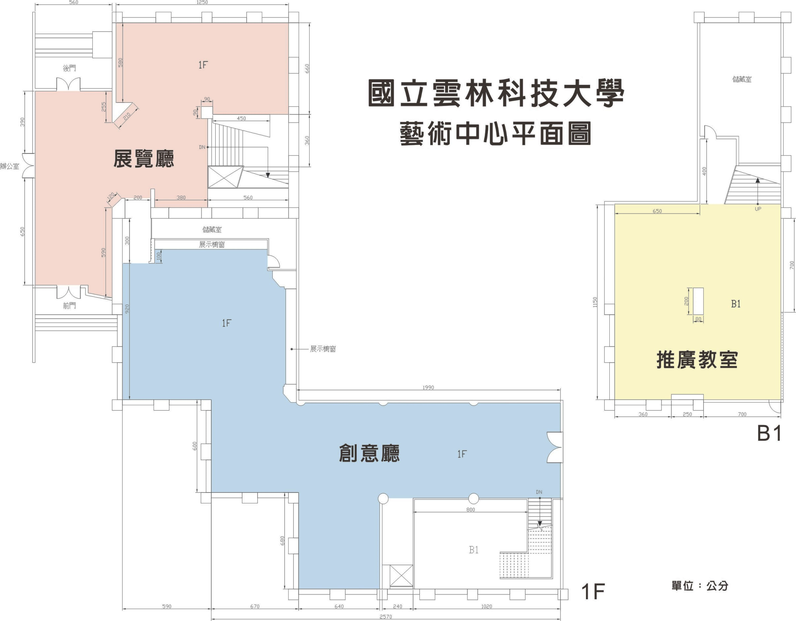
國立雲林科技大學圖書資訊處藝術中心展覽場地平面圖 (Floor Plan)
單位：公分 by cm
雲創廳 Art Muse
雲想廳Art Hub
附件5

